
Ras (Q61L)
Catalog Number:CR-M 26193
Gene Symbol: RAS (Q61L)
Description: Anti-Ras (Q61L) Mouse Monoclonal Antibody

Background: Ras (Q61L) is one type of Ras
missence mutations at codon 61, Ras protein is a membrane-associated GTPase signaling protein that regulates proliferation, differentiation,and cell survival. Ras Q61L mutation result in
decreased GTPase activity and constitutive
signaling, and is correlated with the development of pancreatic intraepithelial neoplasia and lung lesions.
Immunogen: A synthetic peptide from the internal region of Ras which includes the mutation of Q61L, human origin.
Tested applications: ELISA, WB, IHC Recommended dilutions:
ELISA 1:100-1:5000
WB 1:100-1:1000
IHC 1:50-1:100
Concentration: 1 mg/ml
Host: mouse
Clonality: Monoclonal
Isotype: IgG
Purity: Purified from ascites
Format: Liquid Storage buffer:
Preservative: no
Constituents: PBS (without Mg2+ and Ca2+), pH 7.4, 150 mM NaCl, 50% glycerol
Species Reactivity: Recognizes Ras (Q61L), but not wild type Ras protein from vertebrates.
Storage Conditions: Store at -20°C. Avoid freeze / thaw cycles
Western blot:

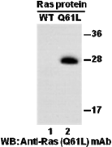
Western blot analysis of recombinant Ras WT
and Q61L proteins. Equal amount of purified Ras WT and Q61L proteins were loaded and blotted with anti-Ras Q61L mouse monoclonal antibody (Cat. # 26193).

For research use only. Not for diagnostic or therapeutic applications.

Immunofluorescence
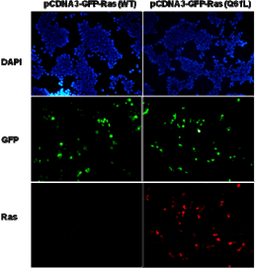
Immunofluorescence of cells expressing Ras proteins with anti-Ras (Q61L) antibody.
HEK293T cells were transfected with
pCDNA3-GFP-Ras (WT) plasmid (left column) or pCDNA3-GFP-Ras (Q61L) plasmid (right column), then fixed and stained with anti-Ras (Q61L) monoclonal antibody (Cat. #26193).

科博瑞（武汉）生物科技有限公司
TEL：027-87615885 15972062685
- mail：3636901710@qq.com
Web:www.coburybio.com

